**Power outages increase cardiovascular and respiratory hospitalizations among US older adults**

**Heather McBrien1*, Daniel Mork2, Vivian Do1, Marianthi-Anna Kioumourtzoglou1, Joan A. Casey3,4**

**1 Columbia Mailman School of Public Health, Department of Environmental Health Sciences**

**2 Harvard T. H. Chan School of Public Health, Department of Biostatistics**

**3 University of Washington Department of Environmental and Occupational Health Sciences**

**4 University of Washington Department of Epidemiology**

**\* Corresponding author:** [**hm2913@cumc.columbia.edu**](mailto:hm2913@cumc.columbia.edu)

**Funding sources:**

**National Institute on Aging grant R01AG071024 (JAC)**

**National Institute of Environmental Health Sciences grant P30ES007033 (JAC)**

**R01ES034021, R01AG066793 (DM)**

**P20 AG093975, P30 ES009089 (MAK)**

**Abstract (max 250 words)**

**Background**: In the US, power outage incidence and duration are increasing with climate change, and power outage exposure is prevalent. Data from New York State show that power outages may increase hospitalizations for cardiovascular disease and respiratory disease in vulnerable populations such as older adults (65+). Limited power outage exposure data has constrained research on power outage and health.

**Question**: Are power outages associated with emergency cardiovascular and respiratory disease-related hospitalizations among older adults in the US?

**Methods**: We developed a new national dataset of hourly county-level power outage exposure, and used these data to identify county-days exposed to 8+ hour power outages in 2018. We used emergency hospitalizations with cause for 23 million Medicare fee-for-service beneficiaries 65+ to produce daily county-level rates of cardiovascular and respiratory-related hospitalizations. We used a case-crossover design with a conditional Poisson model to measure the association between daily county-level power outage exposure and cardiovascular and respiratory hospitalization rates separately, and controlled for temperature, precipitation, and wind speed, and included lag terms.

**Results**: Power outages increased both emergency CVD and respiratory hospitalizations. Effects of outage on CVD hospitalizations were largest the day after power outage exposure (RR: 1.02; CI: 1.013, 1.026). Effects of outage on respiratory hospitalizations were largest the day of outage exposure (1.026, CI: [1.012, 1.039]).

**Conclusion**: Power outages likely cause CVD and respiratory hospitalizations among older adults. Improving electricity reliability could improve community health and protect older adults from CVD and respiratory disease exacerbations from power outage.

**Impact statement:**

**Introduction:**

As the climate warms, the incidence and duration of power outages across the US is increasing.(1) US electrical customers experienced an average of 8 hours without power in 2020—the longest duration on record.(9) 40-60% of these outages were caused by severe weather events.(2) Aging electrical grid components, already at risk of failure, were not built to withstand previously rare extreme weather events now common with climate change.(6),(10) Additionally, climate-change induced heat and cold events will continue to increase electricity use, outstripping supply, and causing outages.(11),(12)

Power outages threaten the health of vulnerable populations such as older adults.(6),(13) Power outages disable air conditioners and heaters, exposing those affected to extreme temperatures.(14) This heat and cold exposure may cause or exacerbate respiratory and cardiovascular illness. Older adults are more likely to suffer health consequences from heat and cold exposure due to aging-related thermoregulation changes(15), or due to preexisting CVD (70-86% of older adults already have CVD)(16). During power outages, loss of electricity to life-sustaining medical devices like at-home ventilators and oxygen tanks can be life-threatening. 3.5% of older adults use electricity-dependent medical equipment such as ventilators and oxygen tanks at home to treat conditions like COPD.(6) Finally, during longer outages, loss of electricity to refrigerators, elevators, wheelchairs, and water disruptions can result in stress, isolation, dehydration, or injury. On average, older adults have higher rates of other underlying health conditions,(17),(18) increased reliance on mobility devices and elevators, and are more socially isolated than younger adults.(19),(20) Therefore, they may have fewer opportunities to seek out electricity, air conditioning, heat, or water to mitigate the effects of an outage, putting them at higher risk for cardiovascular and respiratory illness from outage exposure.

Prior epidemiologic studies using data from New York State have found elevated cardiovascular and respiratory emergency department visits up to one week after power outage exposure for all adults.(3),(4),(5)Associations may be stronger when outdoor temperatures are extreme, and for older adults (65+). However, further research on power outage exposure and health has been limited by exposure data availability. Population-level datasets of power outage exposure beyond New York State have only recently become available. Most studies of outage and health outside of New York use large-scale events such as single hurricanes or other disasters that disrupted power as a surrogate for the timing of power outage exposure in specific locations. These studies consider everyone in a city or county exposed to the power outage in the hours, days, or weeks following the index event. This studies cannot disentangle health effects of outage from health effects of the disaster. Though power outages often occur with severe weather, most power outages do not occur during large disasters. As outages become more common with climate change, understanding the downstream health effects of power outage alone can inform prevention efforts.

In our preliminary work, we assembled the first nationwide dataset describing hourly county-level power outage exposure from 2018-2020, based on data from poweroutages.us. In this paper, we leverage these data together with Medicare hospitalization data to describe the relationship between daily county-level power outage exposure and daily cardiovascular and respiratory hospitalization rates in older adults 65+ in the US nationwide. We also conduct secondary analyses examining effect modification of the effect of power outage on hospitalization rates by age, sex, poverty, and electricity-dependent durable medical equipment (DME) use.

**Methods:**

**Study population:**

Our study population included all fee-for-service Medicare enrollees age 65+, enrolled for at least one month between January 1st, 2018 and December 31st, 2018. From the Medicare enrollee record file, we obtained age, sex, county, and state of residence for all enrollees. We initially included 33,242,414 enrollees.

We used the Medicare Provider Analysis and Review (MEDPAR) file to access inpatient claims data on all hospitalizations in our study population in 2018 from the Center for Medicare and Medicaid Service (CMS). We accessed the date of hospitalization, type of hospitalization (emergency, urgent, or planned), and cause of hospitalization (ICD-10).

**Outcome assessment:**

Using enrollees’ county of residence, we tabulated the number of Medicare enrollees for all US counties in all US states. We also tabulated daily, county-level counts of urgent and emergency hospitalizations for cardiovascular or respiratory causes based on the county of residence on the hospitalized beneficiary. We identified hospitalizations as CVD or respiratory-related based on the first five ICD codes recorded as hospitalization cause. We included only urgent and emergency hospitalizations since we hypothesized only emergency and urgent hospitalization rates would be impacted by power outages and resulting heat, cold, and electricity-dependent medical device disruption in the short term. To identify CVD hospitalizations, we used all codes beginning with I, and for respiratory hospitalizations, all codes beginning with J (**supplemental table X**).

We excluded counties with <=500 beneficiaries due to their unstable hospitalization rates (178 counties had <=500 benes). Our final outcome dataset included daily county-level rates of CVD and respiratory hospitalizations among older adults for n= 2,964, or 94% of US counties.

**Exposure assessment:**

We used PowerOutage.us (POUS) nationwide county-level power outage data to assess county-day power outage exposure for 2018. These data included the number of customers without power every hour by county. ‘Customers’ refers to residential consumers such as households or families and non-residential consumers such as businesses. Estimates of customers served by county from POUS were unreliable. We used EIA estimates of customers served by state to determine total customers in each state. We then used census estimates of the number of households and establishments by county to determine the proportion of state customers in each county, and allocated state customers to each county based on this proportion, estimating the number of customers served by county.

There was substantial exposure data missing from the POUS dataset. In our previous work, we conducted a simulation study to test the impacts of this missing data on an epidemiologic study modelled to represent the study conducted in this paper. We found that when a total of 15% of county-hours were missing from a power outage exposure dataset, results of an epidemiologic study like this one would be biased towards the null by 10%. In order to balance generalizability and bias, we excluded counties with <50% of county-hours non-missing in the POUS data. We excluded 804 counties due to missing exposure data. After excluding counties with low beneficiary counts and missing data, our analytic dataset included 2,161 counties (69%) covering 71.06% of 2018 Medicare beneficiaries (N = 23,622,770). The remaining counties were missing 7% of power outage county-hours. For the included counties, if there were 4 hour or less intervals of missing data, we used last observation carried forward to interpolate those hours.

We considered a county-day exposed to power outage if ≥1% of county customers were without power for 8 or more consecutive hours in each 24-hour period, or ending in each 24-hour period. Since we were interested in understanding the health impacts of common outages, rather than those associated with disasters, we aimed to capture power outages with prevalence. There were on average 7.3 (28.29) 8+ hour power outages affecting ≥1% of the county in each county in 2018. Across counties with varying populations, on average, these outages impact ≥109 fee-for-service Medicare beneficiaries in our study population. Prior studies have also evaluated the health impacts of similar size outages, and found associations between outages and cardiovascular and respiratory health outcomes in all adults and older adults.

We also conducted secondary analyses for power outages affecting ≥3% or ≥5% of county customers, to evaluate the impacts of larger, more rare outages, during which we hypothesized there might be stronger health effects.

We chose to analyze 8+ hour power outages since batteries for most electricity-dependent medical equipment last 8 hours. During a power outage, electricity-dependent medical device users might experience adverse health effects without their equipment immediately after losing power to the equipment. After 8+ hours, we also hypothesized that indoor temperatures would change substantially, exposing older adults to heat and cold.

Because there is no literature on the health-relevant duration of power outage, beyond epidemiologic studies showing that outages of certain lengths have effects, we conducted a sensitivity analysis on the power outage duration evaluating the effects of 4+ hour outages and 12+ hour outages on both hospitalization rates. We also conducted a sensitivity analysis where we used a continuous metric of “daily number of hours without power” (hrs where ≥1% of population is without power) to determine if there were threshold effects for outages longer than a certain duration. We used distributed non-linear lag terms in the conditional Poisson model to determine the relationship between continuous number of hours without power and both outcomes.

As in all available population-level power outage datasets, counts of customers without power reported in this dataset do not necessarily track the same customers. If 10 customers are reported out in two subsequent hours in one county, the data do not contain information about whether the same 10 customers lacked power or if, for example, 10 customers were without power in the first hour and a different 10 customers were without power in the second hour, meaning 20 customers were without power for 1 hour each. Therefore, when measuring exposure to 8+ hour power outages affecting ≥1% of the population, it is not guaranteed that ≥1% of county customers are experiencing 8 consecutive hours of power outage. Though we aim to capture individuals’ exposure to power outage with this definition, there is substantial error. These outages represent some level of large power outage exposure among individuals in a county.

**Statistical analysis**

We used a case-crossover design with a conditional Poisson model to analyze the association between daily county-level power outage exposure and CVD and respiratory hospitalization rates.

We evaluated the effect of outage on CVD and respiratory hospitalizations separately in two different models. We hypothesized power outage may have different effects on these two hospitalization types, since heat, cold, loss of power to medical devices, and dehydration effect CVD and respiratory disease differently. We selected control days for every county-day with non-zero hospitalization count, matching on county, day of week, and month. This matching automatically controlled for county-level confounders like county-level SES, which could affect both hospitalizations rates and power outage rates, and seasonal and day of week trends.

However, this design did not automatically control for time-varying confounders. We controlled for wind speed, temperature, and precipitation, which can all influence both power outage and hospitalization rates. We used daily county-level maximum temperature, average wind speed, and total precipitation measures from gridMET, a dataset of daily high-spatial resolution (~4-km, 1/24th degree) surface meteorological data. We included maximum temperature flexibly in our models as a natural spline with 3 degrees of freedom.

To determine how flexibly to control for wind speed and precipitation, we removed power outage exposure from models and modelled only the relationships between precipitation, wind speed, and CVD and respiratory hospitalization rates separately. We ran several test models with splines on precipitation and wind speed with varying degrees of flexibility (linear, and 2-4 degrees of freedom), and tested model fit using qAICs. We controlled for these confounders in main models with the degree of flexibility that resulted in the best test model fit. In models with the outcome of respiratory hospitalizations, we controlled for precipitation linearly, and in models for CVD outcomes, with 2 degrees of freedom. Wind speed was modeled with 3 degrees of freedom across outcomes.

We hypothesized that there would be lagged effects of power outage on both CVD and respiratory hospitalizations. Power outage exposure was moderately autocorrelated (R = 0.2). We included lags up to 6 days after power outage exposure, and constrained these lags. We tested 3-5 degrees of freedom on the lag dimension, since >5 degrees of freedom seemed biologically implausible. We compared model fit using qAICs, finding that for CVD outcomes, 5 degrees of freedom across the lag dimension produced the best model fit, and 3 degrees of freedom was appropriate for respiratory outcomes.

**Testing for effect modification**

We tested for effect modification of the association of power outage exposure on CVD and respiratory outcomes by age and sex. We stratified analyses by age, for those age 75+ and <75, and by sex (male and female; there is no gender reporting or option to record sex as intersex in CMS records). We also tested for effect modification by poverty status. We calculated the proportion of county households making less than the federal poverty income using 2013-2018 American Community Survey data, and stratified analyses by quartiles of this measure. Finally, we tested for effect modification by the percentage of Medicare beneficiaries using DME by county. We used emPOWER data to estimate the number of Medicare beneficiaries (all, not only those 65+) using DME, and the total number of beneficiaries. We calculated the percentage of DME users by county and stratified analyses by quartiles of percentage of DME users.

**Results**

We included 2,161 counties in our final analysis, covering 71.06% of Medicare fee-for-service beneficiaries. The number of county beneficiaries for included counties ranged from 501 to 252,004. There were on average 7.3 county-level 8+ hour power outages affecting ≥1% of county customers in 2018. The total number of county-days exposed to power outage was 15,990; 2.02% of county-days. The mean daily county-level CVD hospitalization rate was 3.23, and the respiratory rate was 2.25. The most common causes of emergency CVD hospitalization were hypertension, atherosclerotic heart disease (I25.10), acute on chronic diastolic (congestive) heart failure (I50.33) and unspecified atrial fibrillation (I48. 91). The most common causes of emergency respiratory hospitalization were acute respiratory failure with hypoxia (J96.01), acute COPD exacerbation (J44.1), and unspecified COPD (J44.9).

**CVD hospitalizations**

Main analysis

In our main analysis testing the effect of 8+ hour power outage exposure on emergency CVD hospitalization rates, we found increases in CVD-related hospitalizations 1-3 days after power outage exposure, and 6 days after exposure. Exposure was not associated with increased hospitalizations on other lag days. One day following power outage exposure, the CVD hospitalization rate was on average 1.02 (CI: 1.00, 1.01) times higher than on unexposed days.

We also analyzed larger outages affecting ≥3% or ≥5% of county customers. The association between outage exposure and hospitalization was stronger for larger outages. For outages affecting ≥3% of county customers, CVD rates were more elevated than for outages affecting ≥1% of county customers the day after exposure, two days after exposure, and a week after exposure. Outages affecting ≥5% of customers were associated with even higher hospitalization rates. For outages affecting ≥3% of county customers, the day after outage CVD rates were 1.027 times higher than on unexposed days. For outages affecting ≥5% of the population, rates were 1.32 times higher than on unexposed days.

Sensitivity analysis

We conducted sensitivity analyses evaluating the impact of 4+ and 12+ hour outages on CVD hospitalization rates. We also modelled the relationship between daily county-level number of hours without power and CVD hospitalizations.

For 4+ hour and 12+ hour outages, we observed similar results to 8+ hour outages. Hospitalizations were elevated on lag days 1-3 and 6. The effects of 12+ hour outages on CVD hospitalizations were stronger than for 8+ hour outages, and 8+ hour outage effects were stronger than 4+ hour outage effects (**supplemental figure**).

We used distributed non-linear lag terms in the conditional Poisson model to determine the relationship between continuous daily county-level number of hours without power and CVD hospitalization rates, and to test for possible threshold effects.

We used qAICs to find the best-fitting model among eight models. We varied two parameters: we either modelled the exposure-response function as linear or with a natural spline with 3 degrees of freedom, and we also tested 3-6 degrees of freedom on the lag dimension. The best-fitting model was linear between number of hours without power and CVD hospitalizations with 4 degrees of freedom on the lag dimension. For every additional hour without power, the next-day CVD hospitalization rate increased by X (**supplemental figure**).

**Respiratory hospitalizations**

Main analysis

In our main analysis testing the effect of 8+ hour power outage exposure on emergency respiratory hospitalization rates, we found same-day increases in respiratory-related hospitalizations, as well as increases on lag days 1 and 2. In contrast to CVD hospitalizations, the strongest effect of outage on hospitalization was the day of power outage, rather than the day after. On day of power outage exposure, the respiratory hospitalization rate was 1.05 times higher compared to unexposed days.

Effects of larger 8+ outages affecting ≥3% or ≥5% of county customers on respiratory hospitalizations were stronger. For outages affecting ≥3% and ≥5% of county customers respectively, on exposed days, respiratory hospitalization rates were 1.05 times higher and 1.06 times higher than rates on unexposed days.

Sensitivity analysis

For sensitivity analyses evaluating the impact of 4+ and 12+ hour outages, we found strongest effects on respiratory hospitalizations following 12+ hour exposure, with effect size decreasing as duration decreased. Hospitalization rates were X% higher the day of 12+ hour power outage exposure, y% higher with 8+ hour outage exposure, and Z% higher with 4+ hour outage exposure.

Finally, we used distributed non-linear lag terms in the conditional Poisson model to determine the relationship between continuous number of hours without power and respiratory hospitalization rates. The best-fitting model determined by qAIC modelled a linear relationship between number of hours without power and respiratory hospitalizations, with 4 degrees of freedom on the lag dimension. For every additional hour without power, the next-day respiratory hospitalization rate increased by X (**supplemental figure**).

**Effect modification**

We tested for effect modification of the relationship between power outage and CVD and respiratory hospitalizations by age, sex, county-level poverty, and percentage of county Medicare beneficiaries using DME. Overall, we did not observe effect modification by age, sex, or county-level poverty. However, the effect of power outage on respiratory hospitalizations appeared stronger in counties with smaller percentages of DME users (quartile 1 of DME use) compared to counties with larger percentages of DME users (quartile 4 of DME use). Respiratory hospitalizations remained elevated in counties with quartile 1 DME use for two days after power outage, while in counties with fourth quartile DME use, hospitalizations were elevated only on the day of power outage (**Figure**).

**Discussion**

In this study of 23 million Medicare beneficiaries age 65+, we found that power outages increased both emergency CVD and respiratory hospitalizations. Effects of outage on CVD hospitalizations were largest the day after power outage exposure, while effects of outage on respiratory hospitalizations were largest the day of outage exposure. Larger outages affecting ≥3% or ≥5% of county customers had larger effects on hospitalization rates compared to outages affecting ≥1% of county customers. Furthermore, power outages were prevalent. US counties experienced an average of 7.3 8+ hour outages affecting ≥1% of customers in 2018, and shorter outages were even more common. With outage frequency and duration increases due to climate change, these outages pose a serious threat to the cardiovascular and respiratory health of older adults.

Several New York State-based studies have shown that power outages increase CVD and respiratory emergencies, and that the effects of outage on cardiorespiratory health may be stronger in older adults compared to younger adults. Deng et al. showed that both CVD and respiratory adult emergency department visits increased following power outage exposure in New York State, with stronger effects in older adults. Deng et al. found the largest increases in CVD emergency department visits the day after exposure, while respiratory visits increased most the day of exposure; a similar pattern to our results. Using New York State-specific power outage data with high spatial resolution, Do et al. measured the effects of power outage on CVD hospitalizations in Medicare beneficiaries 65+ in New York State from 2017-2018, a study population which overlaps with our study population. Do et al. found elevated emergency CVD hospitalizations one day after power outage exposure, though confidence intervals crossed the null. We estimated similar effects with more precision because of our larger study population.

We hypothesized that power outages lead to CVD and respiratory hospitalizations in older adults because they cause heat exposure, cold exposure, and loss of electricity to life-sustaining medical devices and mobility aids. Power outages may also cause changes in indoor air quality from loss of electricity to dehumidifiers, air purifiers, and ventilation systems. Many power outages are caused by climate-related severe weather like heat waves, winter storms, hurricanes, wildfires, and floods. When outages co-occur with severe weather, health risks may be greater. In this analysis, we controlled for temperature, wind, and precipitation, rather than analyzing effect modification or mediation of the relationship between severe weather, power outage, and hospitalizations. Future studies should examine the health effects of outages and severe weather together. New national datasets of power outage exposure will enable analyses of outage exposure and regional climate hazards together. If power outages mediate the relationship between severe weather and hospitalizations, improving electricity reliability could mitigate the effects of climate hazards.

In this study, larger outages (affecting ≥3% or ≥5% of county customers) were associated with higher hospitalization rates compared to outages affecting ≥1% of county customers. The effects of these outages on hospitalization rates may appear larger because they are measured more accurately in this analysis. There is less exposure misclassification when county-days are considered exposed to power outage when ≥5% of county customers are without power, compared to ≥1% of customers. Exposure misclassification may bias results, likely toward the null, though the magnitude and direction of bias is unknown. However, larger outages may also cause more hospitalizations because they are community-wide events. During a small power outage, older adults may be able to rely on neighbours or other nearby community resources for electricity, heat, or air conditioning. During a larger outage, fewer places still have power. More individuals may therefore be exposed to the midstream effects of power outage such as heat and cold during these large outages, leading to increased hospitalizations.

We tested for effect modification of the effect of power outage on hospitalizations by sex, age, poverty, and DME use. Contrary to our hypotheses, we did not observe effect modification by sex, age, or county poverty quartile. Because we measured poverty at the county level, and wealth varies widely within counties, adaptive capacity may not have been different enough on average between counties classified as high poverty vs low poverty to modify the effects of power outage on hospitalization rates. Finer-grain data may be necessary to test for effect modification. We did observe effect modification by DME use quartile. Counties with higher prevalence of DME use (4th quartile DME use) had lower hospitalization rates after power outage exposure compared to counties with lower DME use (1st quartile). We hypothesized the opposite: that DME users would be more vulnerable to health effects from power outage compared to non-DME users. We are unsure why we observed these effects but offer several potential explanations. First, power outages could also be causing mortality rather than hospitalizations among DME users. Second, DME users may be more prepared for outages compared to non-DME users, and have access to generators or back up batteries. Third, all DME users may not be equally vulnerable to health effects from power outage. We measured county DME use based on how many Medicare beneficiaries used any kind of DME, including wheelchairs, beds, oxygen equipment, ventilators, alternative communication devices, and more. People using life-sustaining DME such as oxygen and ventilators may be more vulnerable to health effects from power outage than other DME users. At the same time, use of other DME types may be indicative of better access to health care, and higher adaptive capacity. Data on DME use are not disaggregated by type of DME for the year 2018, limiting further analysis.

Strengths and limitations

In this study we measured county-level power outage, since no national finer-resolution power outage exposure data are available. We considered a county-day exposed to power outage if ≥1% of county customers were without power for 8+ consecutive hours. This definition of power outage exposure can misclassify up to 99% of customers as exposed when they are not experiencing a power outage. Because power outage is an understudied exposure, it is unclear how measuring power outage at this spatial unit level with this exposure misclassification could bias the results of this study. This question could be addressed in a simulation study or with individual-level power outage data.

We also measured poverty and DME use, potential effect modifiers, at the county level. Because counties are large and diverse, this likely impacted our results.

Finally, the POUS dataset we used to measure exposure is missing substantial amounts of data. We chose to exclude counties missing more than 50% of customer-hours in 2018, to balance generalizability and bias from missing data, using results from our previously published simulation paper to guide this decision. Many counties missing >50% of exposure data were rural counties with low customer counts. Other studies of power outage and health have found differential effects of power outage on health by urban or rural status. Because we excluded so many rural counties, our results may not accurately represent the effect of outage on health in rural counties.

Despite these limitations, this study is the first US national study of power outage and health outcomes. We had adequate power to detect effects of power outage on health, making our results more precise and generalizable than studies limited to New York State. Our choice of a case-crossover design automatically controlled for many potential county-level confounders, and we studied a large population of 23 million older adult fee-for-service Medicare beneficiaries.

**Conclusion**

In this national study of power outage exposure among older adult Medicare beneficiaries, we found that power outages were associated with increased CVD and respiratory hospitalization rates. Power outages are prevalent in the US, and the incidence and duration of outage exposure is increasing with climate change. Improving electricity reliability could improve community health and protect older adults from CVD and respiratory disease exacerbations. More research is needed to evaluate the effects of co-occurring power outages and severe weather on cardiorespiratory health, since hospitalization risks may be greater when power outages co-occur with heat, winter storms, or other climate-related weather events.

**Tables and Figures**

**Table 1:**

|  |  |  |  |  |  |
| --- | --- | --- | --- | --- | --- |
| Distribution of power outage by potential confounders | | | | | |
|  | | | | Proportion of county-days with 8+ hour power outage affecting ≥1% of county customers by potential confounder quartiles | |
| Wind speed | | | | | |
|  | | Quartile 1 | | 0.009 | |
|  | | Quartile 2 | | 0.009 | |
|  | | Quartile 3 | | 0.010 | |
|  | | Quartile 4 | | 0.022 | |
| Precipitation | | | | | |
|  | | Quartile 1 | | 0.013 | |
|  | | Quartile 2 | | 0.014 | |
|  | | Quartile 3 | | 0.012 | |
|  | | Quartile 4 | | 0.011 | |
| Daily maximum temperature | | | | | |
|  | | Quartile 1 | | 0.022 | |
|  | | Quartile 2 | | 0.012 | |
|  | | Quartile 3 | | 0.009 | |
|  | | Quartile 4 | | 0.008 | |
|  | |  | |  | |
| Distribution of power outage by demographic variables | | | | | |
|  | | | Number of county beneficiaries by category | | Proportion of county-person-days with 8+ hour outage affecting ≥1% of county customers |
| Sex | | | | | |
|  | Male | | 10,813,568 | | 0.013 |
|  | Female | | 12,809,202 | | 0.012 |
| Age | | | | | |
|  | 75 or older | | 9,784,741 | | 0.013 |
|  | 65 - 75 | | 13,838,029 | | 0.012 |
| % county population with income < 2020 census federal poverty level | | | | | |
|  | Quartile 1 | | 8,214,604 | | 0.012 |
|  | Quartile 2 | | 6,542,974 | | 0.011 |
|  | Quartile 3 | | 6,000,194 | | 0.014 |
|  | Quartile 4 | | 2,864,998 | | 0.014 |
| % of county Medicare beneficiaries using durable medical equipment | | | | | |
|  | Quartile 1 | | 14,203,491 | | 0.008 |
|  | Quartile 2 | | 5,343,736 | | 0.017 |
|  | Quartile 3 | | 2,663,919 | | 0.019 |
|  | Quartile 4 | | 1,411,624 | | 0.020 |
| All | | | 23,622,770 | | 0.013 |

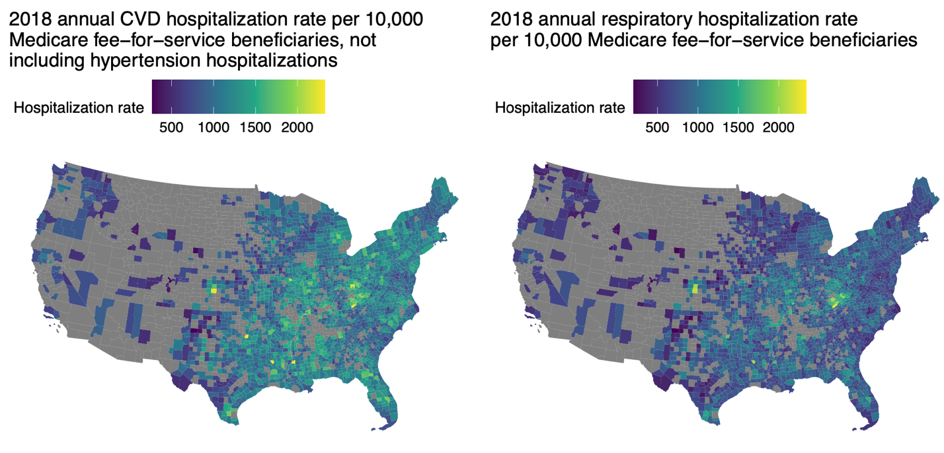

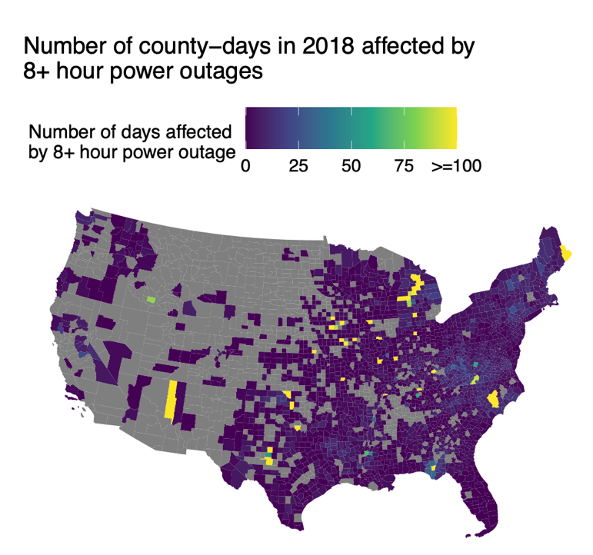

**Figure 1:** 2018 county cardiovascular hospitalization rate, respiratory hospitalization rate, and power outage rate for counties included in main analysis of association between 8+ hour power outage exposure and cardiovascular and respiratory hospitalization.

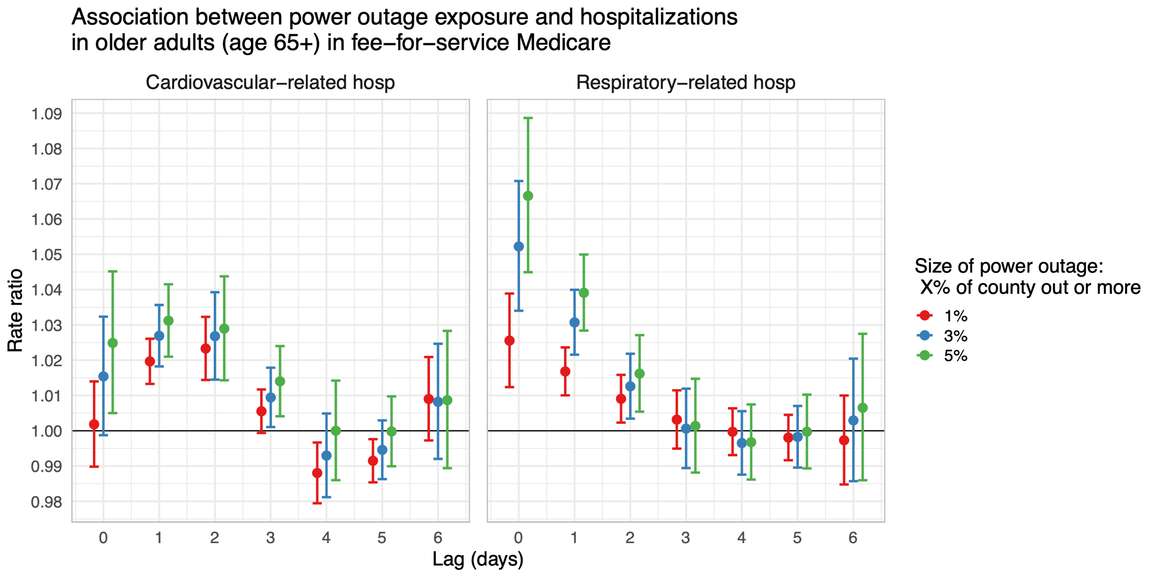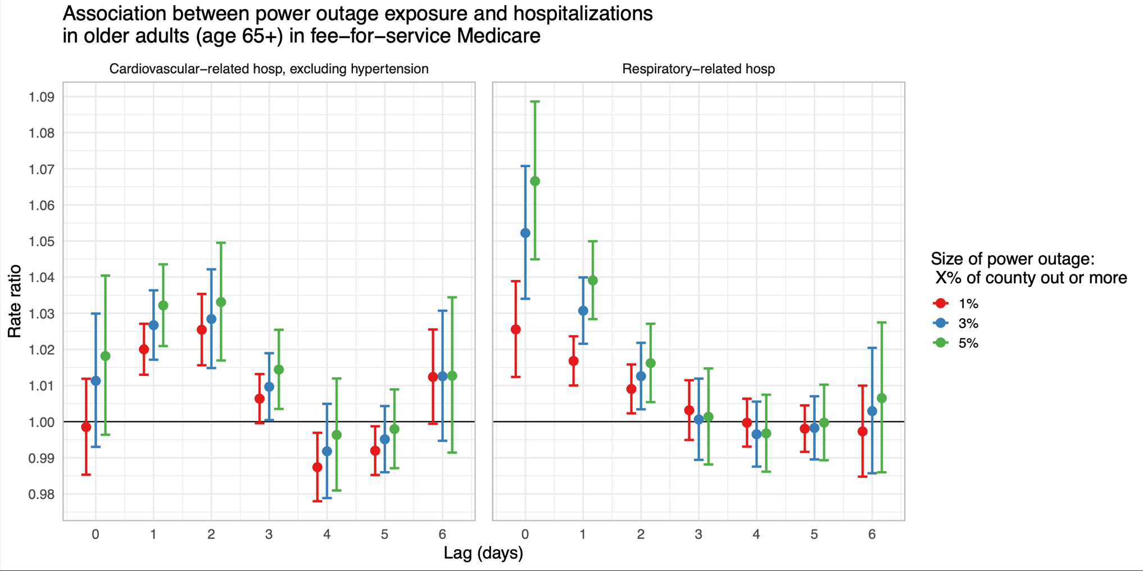

**Figure 2:** Estimates and confidence intervals for the association between 8+ hour power outage exposure and CVD and respiratory hospitalizations in US 2018 fee-for-service Medicare beneficiaries for outages affecting ≥1%, ≥3%, and ≥5% of county electrical customers.

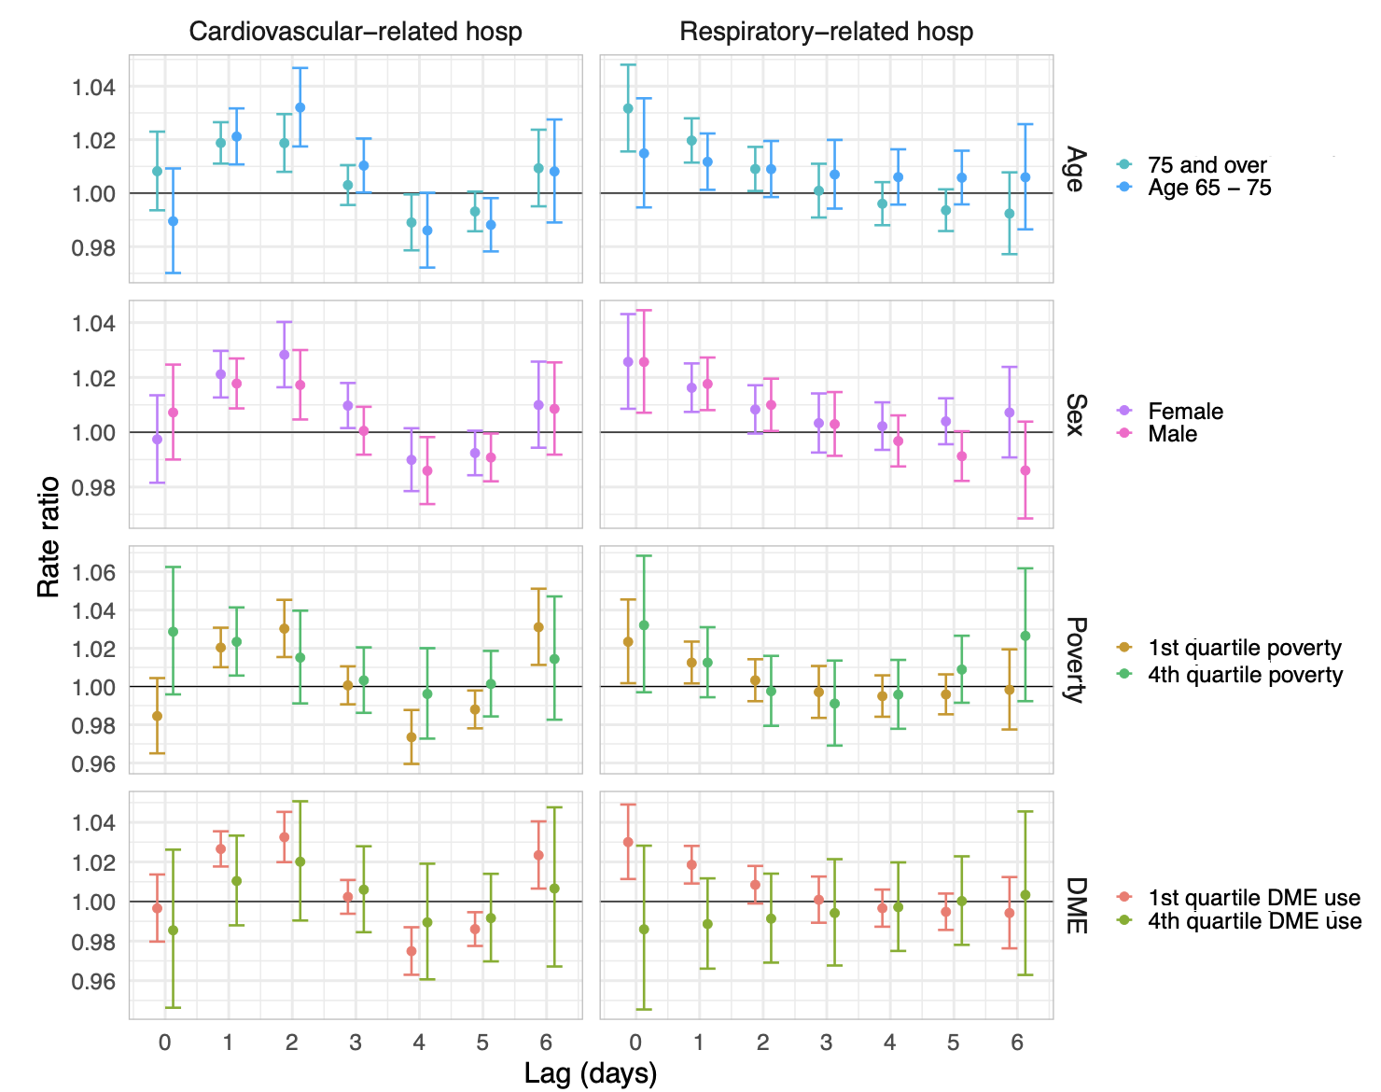

**Figure 3:** Estimates and confidence intervals for the association between 8+ hour power outage exposure and CVD and respiratory hospitalizations in US 2018 fee-for-service Medicare beneficiaries by potential effect modifiers: age, sex, county poverty quartile, and county DME use quartile.